Realm Swift



Install REALM Studio or Browser

Browser:

<https://github.com/realm/realm-browser-osx/releases/>

cmd+shift G

<https://github.com/realm/realm-browser-osx>

Studio:

<https://realm.io/products/realm-studio/>

-------------------------------------

Install Cocoa Pods

more ref:

<https://realm.io/docs/swift/latest/>

**Configure Cocoa Pods into xcode project**

**create podFile**

**in the console execute**

pod init

**Update the PodFile and add a library**

**update PODFILE:**

# Uncomment the next line to define a global platform for your project

#platform :ios, '9.0'

target 'FoodTracker' do

# Comment the next line if you're not using Swift and don't want to use dynamic frameworks

use_frameworks!

#link_with 'FoodTracker', 'FoodTracker WatchKit Extension'

# Pods for FoodTracker

pod 'RealmSwift'

pod SwiftJSON

target 'FoodTrackerTests' do

inherit! :search_paths

# Pods for testing

end

end

**execute Pod install**

pod install

**close the project and open using console , afert intall cocoa pods you can open your project with extention: xcworkspace**

open FoodTracker.xcworkspace

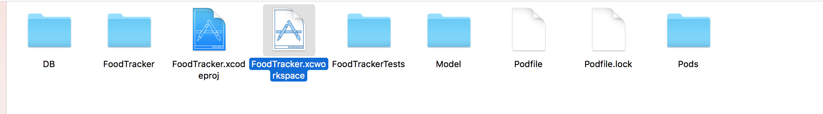

**Build the Project**

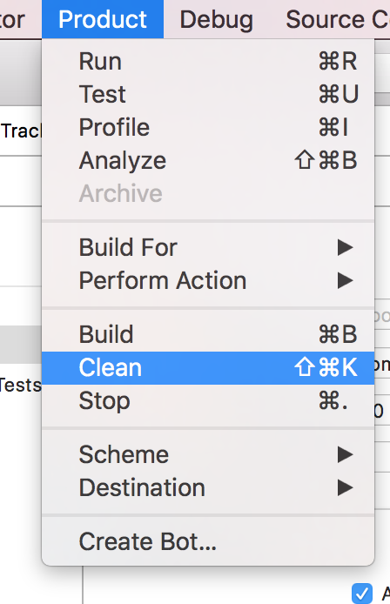

**Create DataBase Model**

**1.- create a Group and put name “DB”**

**2.- Create a New Swift File,**

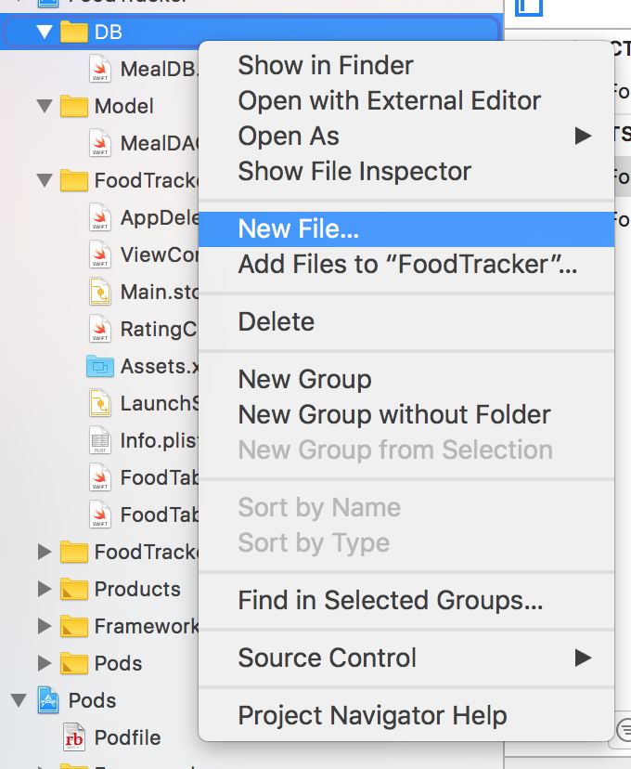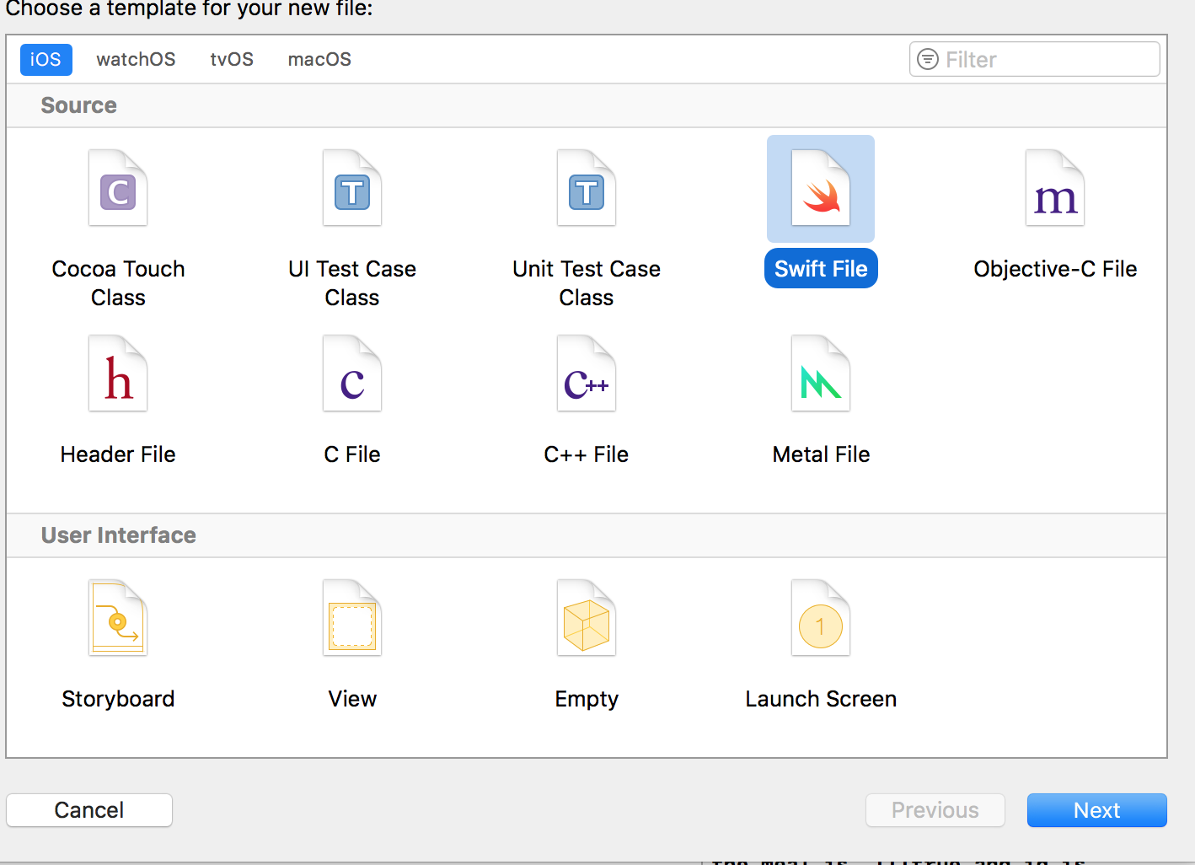

**Create File with Name MealDB**

**//**

**// MealDB.swift**

**// FoodTracker**

**//**

**// Created by jbian on 11/16/17.**

**// Copyright © 2017 Apple Inc. All rights reserved.**

**//**

**import Foundation**

**import RealmSwift**

**class MealDB:Object{**

**@objc dynamic var id:String?**

**@objc dynamic var name:String?**

**@objc dynamic var photo:NSData?**

**@objc dynamic var raiting:Int = 0**

**@objc dynamic var city:String?**

**override static func primaryKey() -> String?{**

**return "id"**

**}**

**}**

# SETUP

* UPDATE MEAL MODEL

UPDATE MEAL MODEL TO MAPPING MEAL MODEL TO REALM DATABASE AND INCLUDE THE “Id” attribute into Model if you want you can refactor the name of class to MealDAO

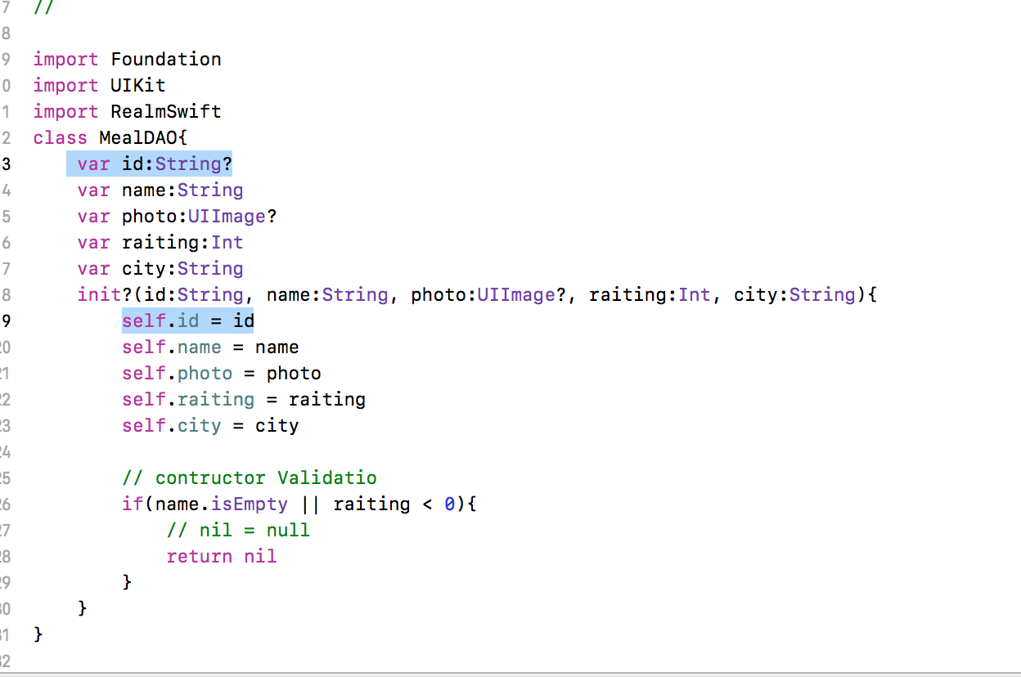

also update all places where the Meal is referenced and used:

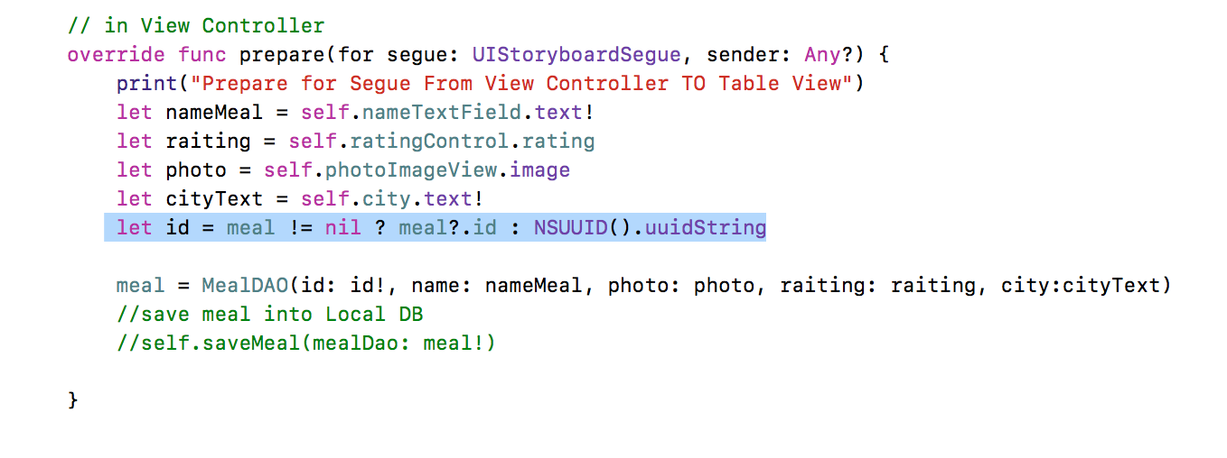

For setup realm import the library : “RealmSwift” and create the atribute realm:Realm? in the TableViewController and in the method viewDidLoad call : realm = try! Realm()

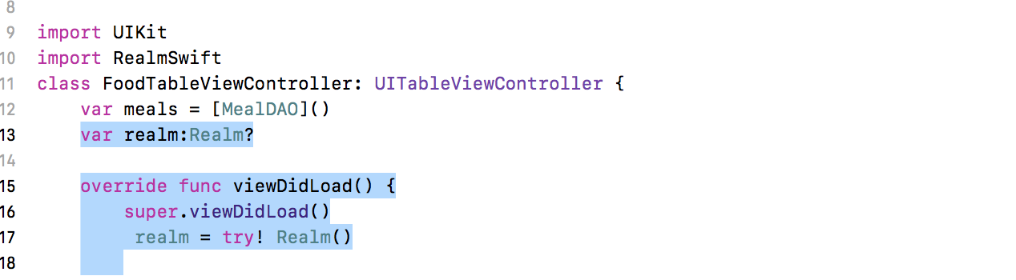

# Retrieve Data

in MealTableViewController Metodo ViewDidLoad implements following lines

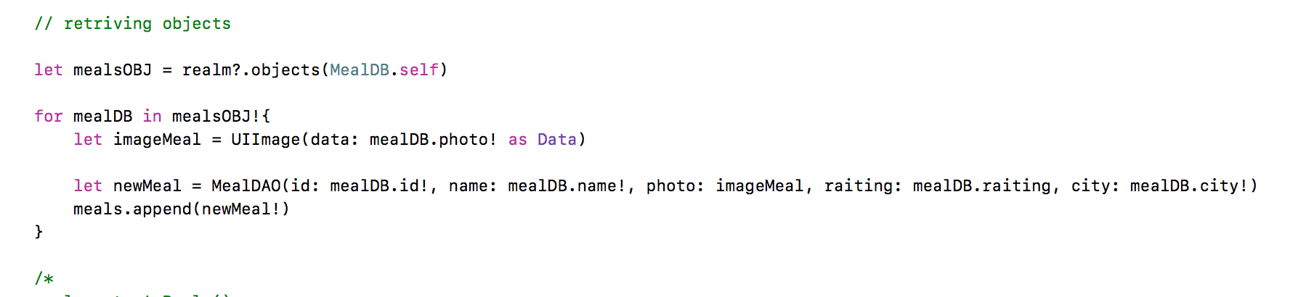

# 

# Save Data

int MealTableViewController implement the following fuction:

func saveMeal(mealDao: MealDAO){

let newMeal = MealDB()

newMeal.id = mealDao.id

newMeal.name = mealDao.name

newMeal.city = mealDao.city

newMeal.raiting = mealDao.raiting

// convert image to

//let data = UIImagePNGRepresentation() as NSData?

newMeal.photo = UIImagePNGRepresentation(mealDao.photo!)! as NSData

print ("the uuid --> \(UIDevice.current.identifierForVendor)")

try! self.realm?.write {

print("Save !!! --Paht --> \( Realm.Configuration.defaultConfiguration.fileURL)")

self.realm?.add(newMeal)

}

}

Call this function from UnwidToMealList in the “else “

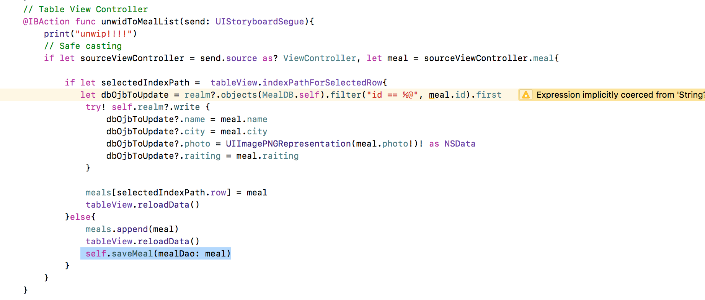

# Delete Data

In to table view controller update the method: Editing style the method where you add functionality for delete a row of the table

and include followin lines:

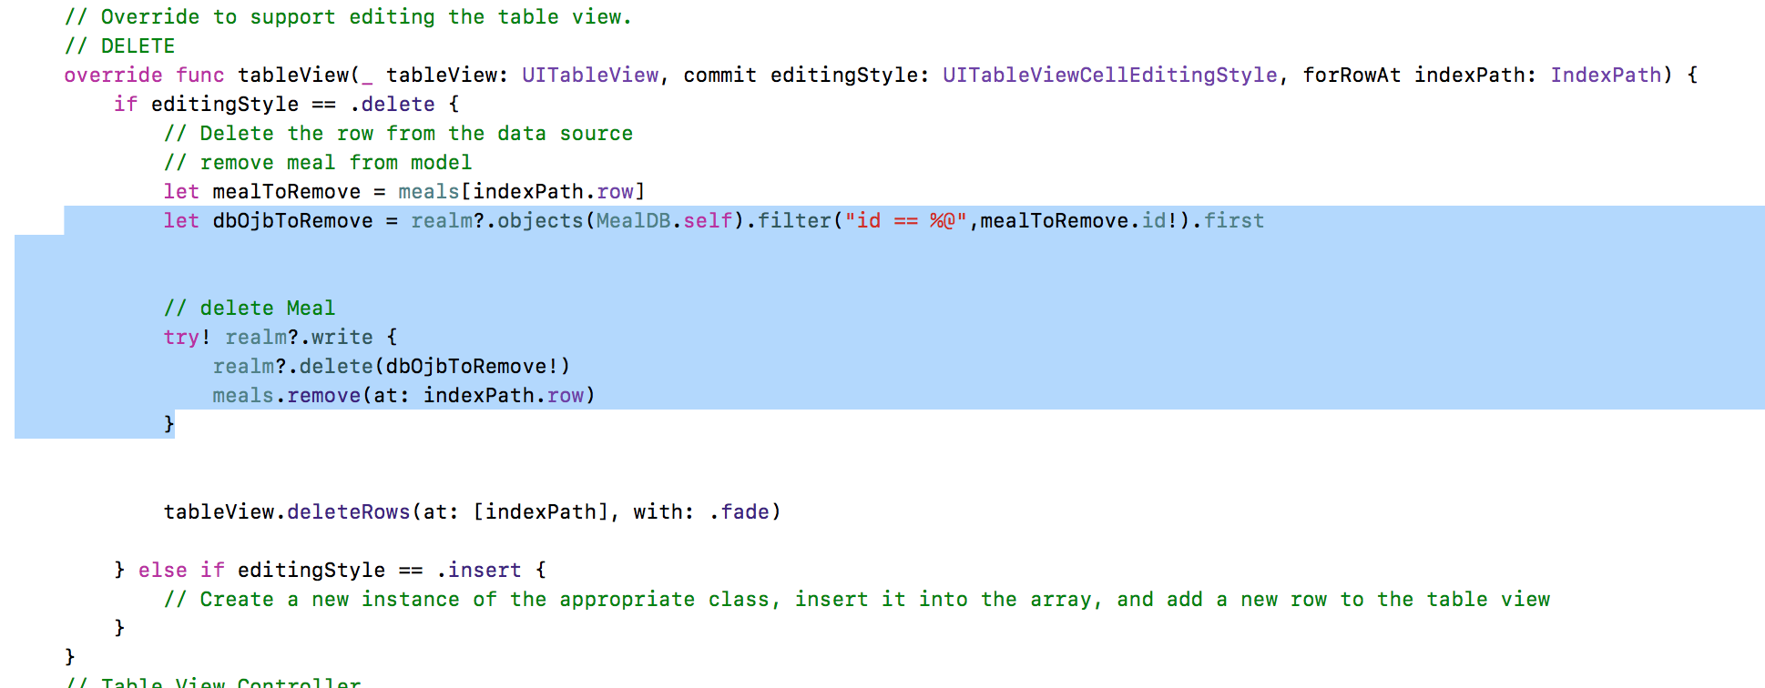

# Update Data

in the @IBAcction of “unwip” add the followin lines

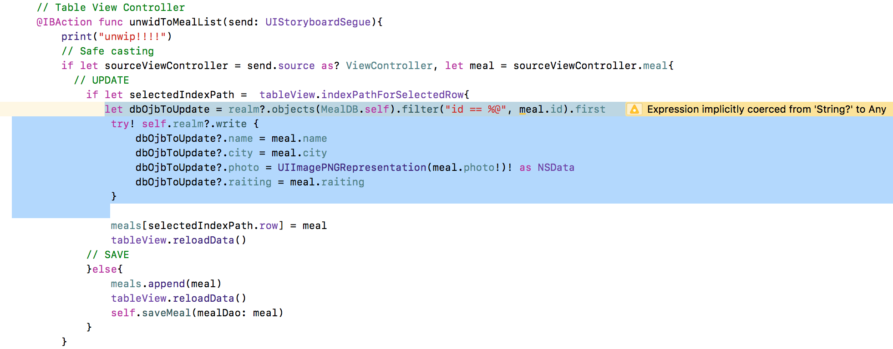

**How to See where save the .realm file**

**print("Save !!! --Paht --> \( Realm.Configuration.defaultConfiguration.fileURL)")**

**open console and goto this location and open .real file with realm explorer:**

